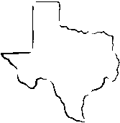
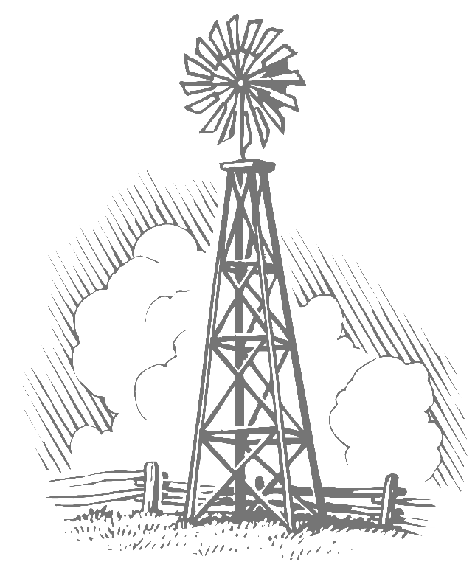
Fayette County Groundwater Conservation District
255 Svoboda Lane, Room 115
La Grange, Texas 78945
Telephone: (979) 968-3135
Fax: (979) 968-3194

NOTICE OF MEETING
OF THE BOARD OF DIRECTORS
FAYETTE COUNTY GROUNDWATER CONSERVATION DISTRICT

Notice is hereby given that a Public Hearing of the Fayette County Groundwater Conservation District will be held on the 13th day of September, 2021, at 9:30 a.m., at which time the following subjects will be discussed, to wit:

A G E N D A
Matters to be discussed that are subject to vote by the Directors of the Fayette County Groundwater Conservation District are as follows:

- Call to order.
- Public hearing to receive public comment on the District’s proposed 2021 tax rate.
- Consider and take appropriate action on the District’s proposed 2021 tax rate.
- Adjournment.

Agenda items may be considered, deliberated and/or acted upon in a different order than set forth above. At any time during the meeting and in compliance with the Texas Open Meetings Act, Chapter 551, Government Code, Vernon’s Texas Codes, Annotated, the Fayette County Groundwater Conservation District Board may meet in executive session on any of the above agenda items for consultation concerning attorney-client matters (§551.071); deliberation regarding real property (§551.072); deliberation regarding prospective gifts §551.073 ; personnel matters (§551.074); and deliberation regarding security devices (§551.076). Any subject discussed in executive session may be subject to action during an open meeting.

