
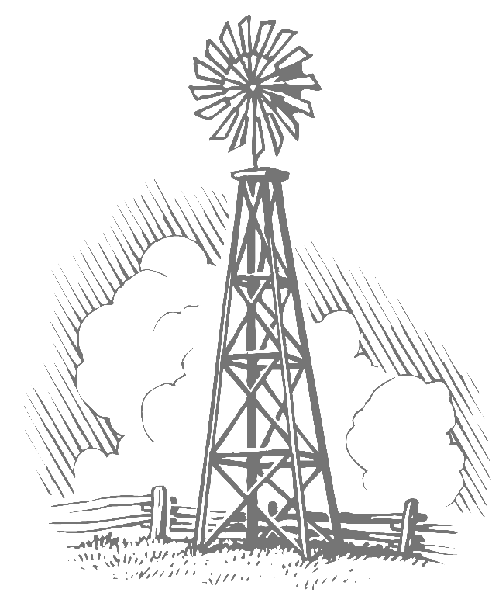
Fayette County Groundwater Conservation District

255 Svoboda Lane, Rm. 115
La Grange, TX 78945
979-968-3135
www.info@fayettecountygroundwater.com

Constructing an Inexpensive Rain Barrel for Your Home

It is no surprise that Texas summers are hot and dry. What can be a surprise is the fact that well over 50% of all water usage in Texas, during the summer, is for outdoor watering purposes. Plants, trees, and our lawns are important aspects of our lives and can be cared for while also working to conserve that most valuable resource….water.

One inexpensive way to reduce demand on your well or municipal system is to construct and inexpensive rain barrel. This fun family project takes only a few minutes to construct and offers a free water supply for watering your flowerbeds or small garden areas.

IMPORTANT NOTE: The water collected in this rain barrel system is not for drinking and should be used only for watering of plants, grass, and trees.

Material:
- One heavy walled 30 gallon green or black trash can with lid. (White or clear trash cans can allow too much sunlight into the container and allow algae to grow on the walls.)
- ¾ inch hose bib. (Any size will work, but the model illustrated uses a ¾ inch bib.)
- Silicone sealant
- Teflon tape or thread sealant
- Fitting to secure hose bib to the wall of the trash can.
- Window screen material. (Make sure the screen will cover the opening of the trash can with a few inches overhanging the sides)
- Two or three metal screws
- Fittings for downspout diversion
- ¾ inch hole saw
- Tin snips, heavy duty scissors, or heavy garden shears
- Drill
- screwdriver
- Two or three standard cinder blocks.
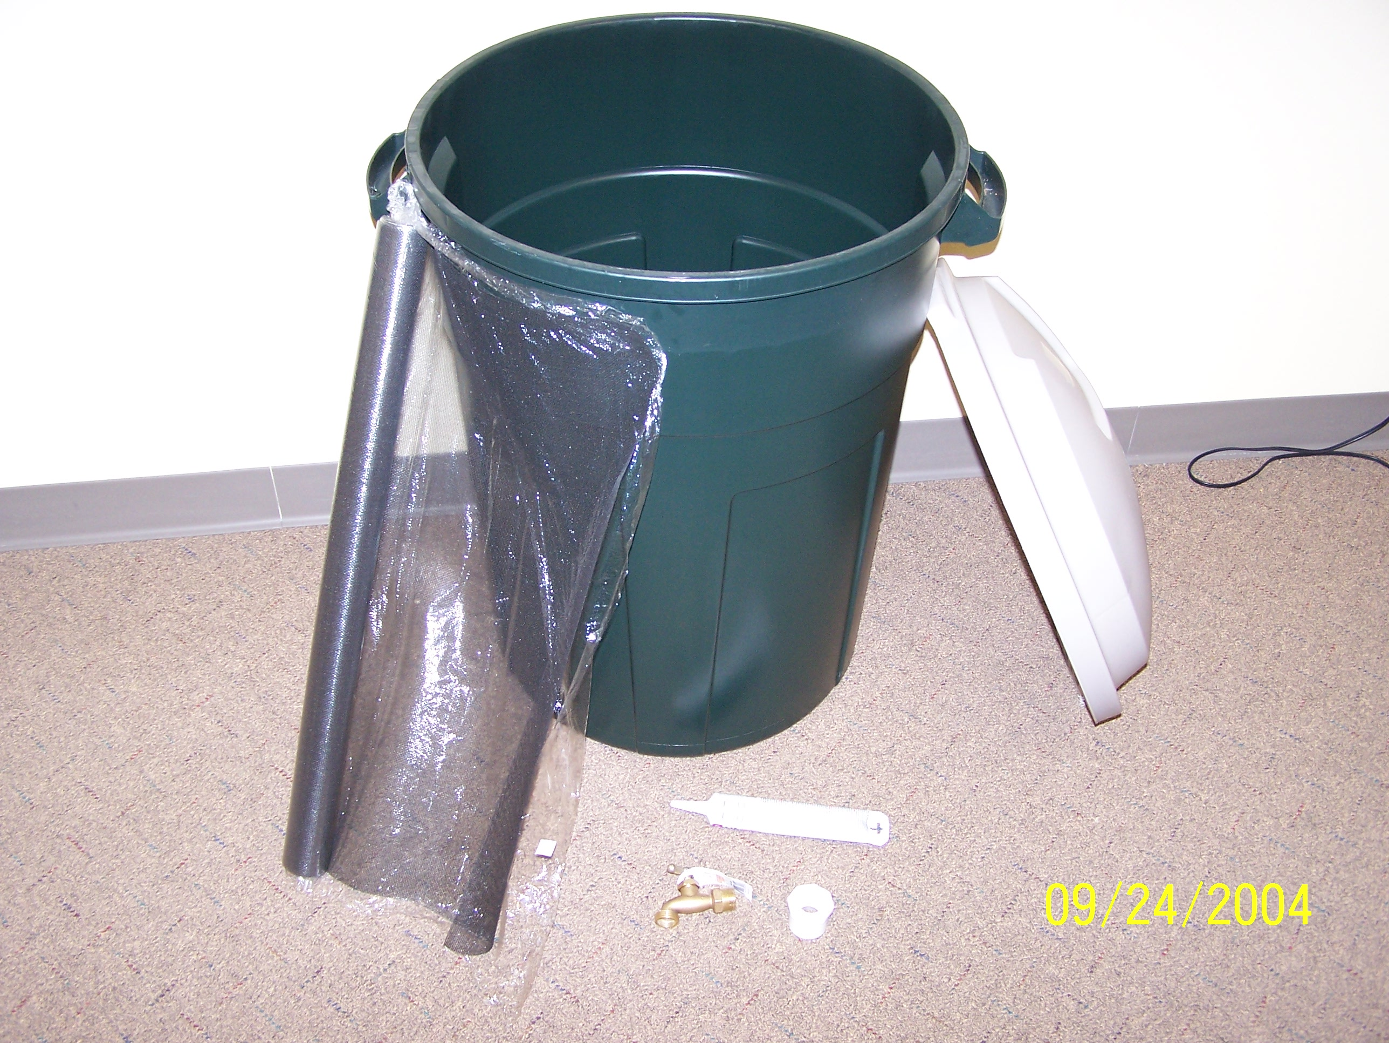

Construction:
  - Using the hole saw, drill a hole for the hose bib approximately 2-3 inches up from the bottom of the trashcan.
  - Cover the threads of the hose bib with Teflon tap or thread sealant and install through the hole.
  - Secure the hose bib in to the hole using the fitting. Don’t over tighten if using plastic fittings.
  - Silicone around the fitting inside the can and around the hose bib outside the can.
  - Using the shears or scissors cut a piece of the screen material that will allow approximately three to four inches of overlap over the opening of the trash can.
  - Center the screen material and secure the screen, along the top rim, on one side of the trash can. (This is to catch debris and to prevent mosquitoes form breeding in the barrel)
  - Pull the screen tight with one hand and secure the lid of the trash can. If your trash can does not have a lockable lid you may need to secure the screen material in several spots only the rim of the trash can.
  - Using the shears or tin snips, create a hole in the top of the lid to accept the downspout fitting. The hole should be slightly larger than the fittings to allow for easy removal of the lid for cleaning and inspection.
  - Find a suitable location for the rain barrel and level out an area as close to a downspout as possible.
  - Place the cinderblocks on the ground and level.
  - Place your newly constructed rain barrel on the cinder blocks adjusting the hose bib and lid opening for easy access and acceptance of the downspout fittings.
  - Cut the existing downspout a few feet higher than the top of the rain barrel.
  - Using fittings to plumb the downspout to the opening in the rain barrel and secure as necessary.

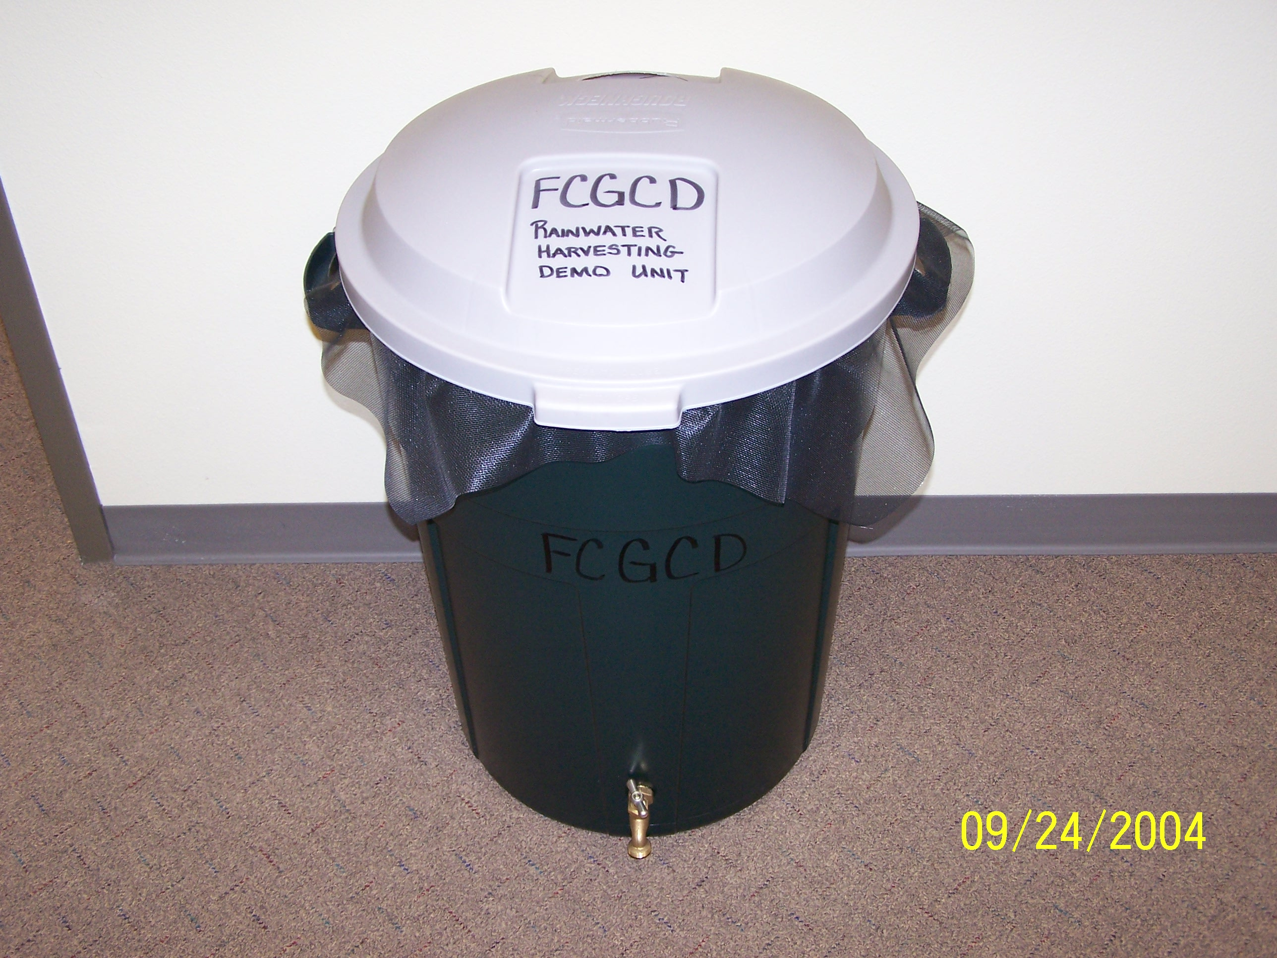

A few things to remember regarding your rain barrel:

- Make sure the area that you place the rain barrel is level. Water is heavy and you do not want the barrel toppling over.
- Clean your gutters. The less debris flowing down the downspout means less cleaning and possible damage to the screen in the rain barrel.
- This system runs on gravity but if you are wishing to use a drip system need pressure a submersible pump can be installed easily.
- Clean out sediments in the rain barrel once a year or as needed. Clean the screen often.
- Have fun with this project and remember you are doing your part to conserve water.

