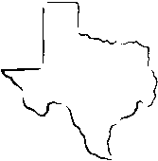
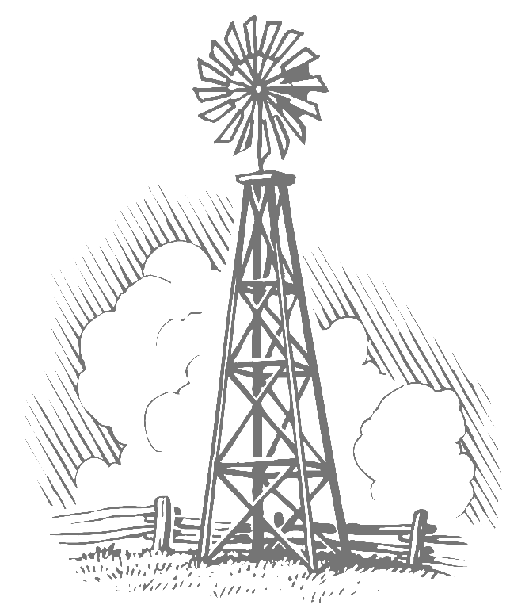
Fayette County Groundwater Conservation District
255 Svoboda Lane, Room 115
La Grange, Texas 78945
Telephone: (979) 968-3135
Fax: (979) 968-3194

MINUTES
of the September 12, 2021, 9:30 A.M.,
Public Hearing Concerning the
District’s Proposed 2022 Tax Rate

Directors Present: | Leo Wick, Sr., Cynthia Rodibaugh, Terry Hays, Harvey Hayek,
Directors Absent: | Robert Leer
Others Present: | David A. Van Dresar, General Manager; Wendi Pyle, Administrative Assistant, Paul Kirby, Daniel B. Stephens & Associates

The public hearing was called to order by President Wick at 9:30 a.m. on September 12, 2022. A quorum to conduct business was declared to be present.

President Wick asked for any public comment regarding the proposed tax rate. There were none.

Ms. Pyle informed the board that district staff recommended lowering the tax rate from the previous tax year to .0084.

Mr. Hayek made the motion to set the tax rate for fiscal year 2022 at $0.0084 per $100 valuation. Mr. Hays seconded the motion.

Ms. Pyle read the tax rate resolution into the record. The proposed tax rate of $0.0084 per $100 valuation was presented. This tax rate is a decrease from the 2021 adopted tax rate for the District. The proposed tax rate would increase the total taxes in the Fayette County Groundwater Conservation District by .59%.

There being no further discussion, President Wick asked for a vote on the proposed tax rate. Ms. Pyle conducted a roll call vote. The motion was approved with Mr. Hayek, Mrs. Rodibaugh, Mr. Hays, and Mr. Wick voting aye. No director voted nay. Mr. Leer was absent.

There being no further items on the agenda, Mrs. Rodibaugh made the motion to adjourn the public hearing. Mr. Hayek seconded the motion. With no objections, President Wick adjourned the public hearing on the District’s Proposed 2022 Tax Rate at 9:35 a.m.

Leo Wick, Sr., President Cynthia Rodibaugh, Secretary/Treasurer

