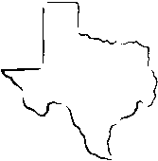
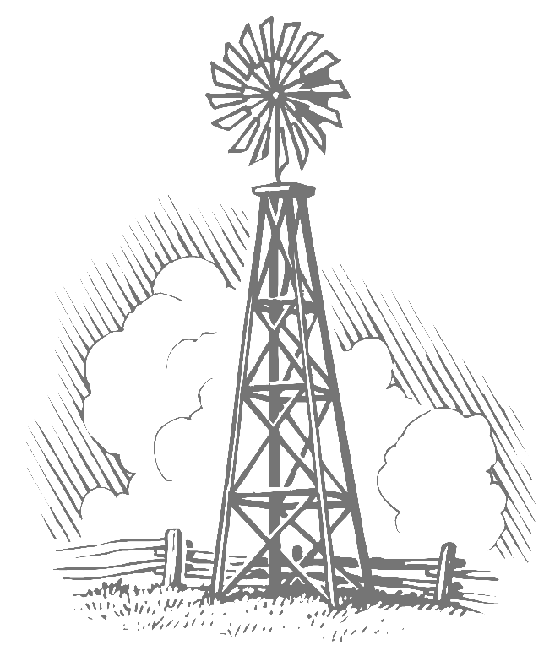
Fayette County Groundwater Conservation District
255 Svoboda Lane, Room 115
La Grange, Texas 78945
Telephone: (979) 968-3135
Fax: (979) 968-3194

MINUTES
of the September 11, 2023, 9:30 A.M.,
Public Hearing Concerning the
District’s Proposed 2023 Tax Rate

Directors Present: | Leo Wick, Sr., Cynthia Rodibaugh, Mark Heinrich, Harvey Hayek, Robert Leer
Directors Absent: | None
Others Present: | David A. Van Dresar, General Manager; Wendi Pyle, Administrative Assistant; Monique Norman, Legal Counsel; Paul Kirby, Daniel B. Stephens & Associates

The public hearing was called to order by President Wick at 9:35 a.m. on September 11, 2023. A quorum to conduct business was declared to be present.

President Wick asked for any public comment regarding the proposed tax rate. There were none.

Mr. Van Dresar informed the board that district staff recommended lowering the tax rate from the previous tax year to $0.0082/$100 valuation. Mr. Van Dresar presented how staff calculated the proposed tax rate.

Ms. Pyle read the tax rate resolution into the record. The proposed tax rate of $0.0082 per $100 valuation was presented. This tax rate is a decrease from the 2022 adopted tax rate for the District. The proposed tax rate would increase the total taxes in the Fayette County Groundwater Conservation District by 9.48%.

Mrs. Rodibaugh made the motion to set the tax rate for fiscal year 2023 at $0.0084 per $100 valuation. Mr. Heinrich seconded the motion.

There being no further discussion, President Wick asked for a vote on the proposed tax rate. Ms. Pyle conducted a roll call vote. The motion was approved with Mr. Leer, Mrs. Rodibaugh, Mr. Heinrich, and Mr. Wick voting aye. No director voted nay. Mr. Hayek was abstained.

There being no further items on the agenda, President Wick adjourned the public hearing on the District’s Proposed 2023 Tax Rate at 9:45 a.m.

Leo Wick, Sr., President Cynthia Rodibaugh, Secretary/Treasurer

